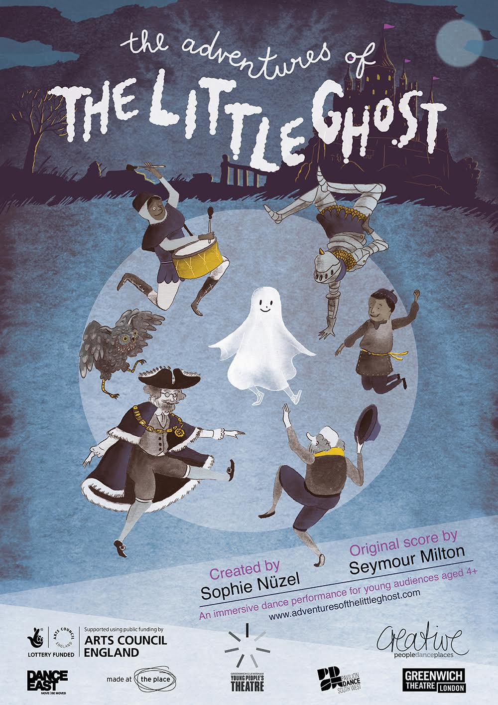

The Adventures of The Little Ghost
A show for young audiences aged 4+
Directed and created by Sophie Nüzel
Supported by Arts Council England

Dancers:
John Ross
Nathan Johnston
Jacob Smart
Thomas Hand
Harvey Halpenny and Salvador Foster - Thylmann
Creative Team
Original Score and Sound Design by Seymour Milton
Set Design-Ben Pacey
Lighting Design-Charlie Lucas
Costumes-Rachel Antonio
Production Manager-Ed Yetton
Producer-Rachel Evans
Project Manager-Annie Taylor-Gooby
Tour Dates 2016
9th July-DanceEast
30th October-Pavillion Dance
19th & 20th November-The Place

Logistics

- Running time: 45minutes

- The piece is performed in the round and has been developed to be viewed by an audience of approx. 100 per show.

- The minimum space requirement for this show is 14 metres x 14 metres.

- This piece is for young and old audiences. (Please note that the piece is not suitable for 0 - 4 year olds)

- We recommend 4 performances over 2 days with a maximum of up to two performances per day.

- The cast consists of 4 male professional dancers, a young boy plus a community cast, recruited by each venue, of up to 30 people aged 10 – 101.

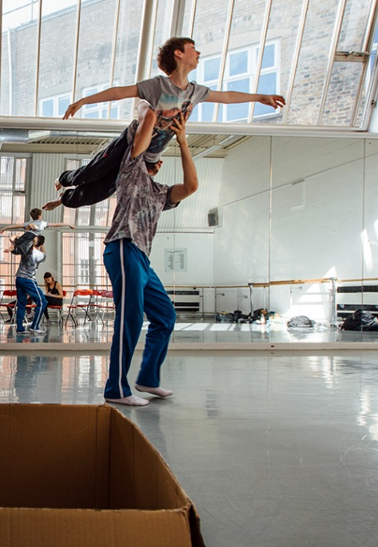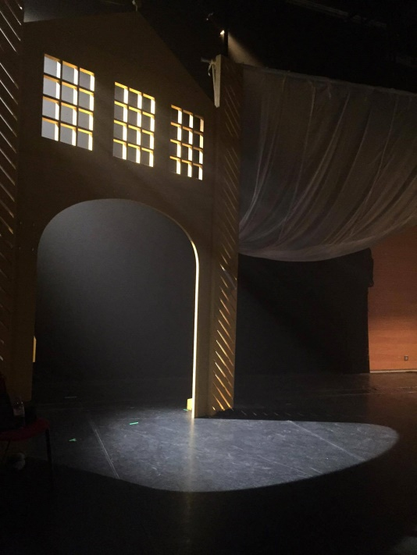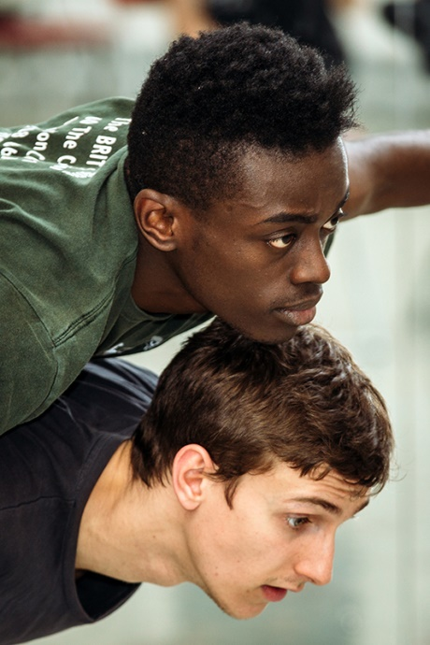

For further information please contact Sophie on 07828 315121 or Sophienuezel@gmail.com
The Show
‘The Adventures of The Little Ghost’ is a new show for young audiences choreographed by Sophie Nüzel with an original soundscore by Seymour Milton. Based on the book ‘The little Ghost’ by Ottfried Preussler the piece engages the audience into a magical, immersive world that unfolds before their eyes as soon as they enter the space. The audience sit in-the-round, the show taking place all around them, creating an adventurous and engaged feel as the audience discover new characters and scenes over the course of the event. The piece uses a mix of dance styles including elements of parkour and freerunning.
In a locked chest in a dusty attic of a very old castle lives The Little Ghost. At the stroke of midnight each night The Little Ghost wakes up. He haunts the castle, visits the knights as well as his friend the owl. At the stroke of one, he falls asleep in his chest. His greatest wish is to see the world in daylight, just once. But how can he make his wish come true? And what will the townsfolk make of a ghost in the daytime?
Working with a core cast of 3 professional dancers, a freerunner as well as a young dancer as The Little Ghost, this piece invites a community cast of up to 30 people aged 10 – 100 years old at each performance venue, providing an intensive artistic experience for each participant. The aim is to engage people of all backgrounds and abilities in a high quality dance experience both as performers as well as audiences.

Community Engagement
Who?
The community cast exists of 30 people aged 10+ . We have split them into Group A and Group B: Group B consists of everyone, Group A does an extra part and will therefore require a little bit more rehearsal time.

Group A) Young company aged 10-14 years, ideally 15 dancers
Group B) Adult Company aged 18+ plus Group A

The total number of community cast participants shall not exceed 30 people.

The recruitment of the community cast is responsibility and choice of the host organisation. The community cast can be a newly recruited group, an already existing group, a school class and their teachers as well as other groups the organisation might like to work with.
We do offer a taster workshop prior to the project should the organisation wish to hold one.
How?
Although we are slightly flexible when and how we rehearse with the community cast we suggest the following:
- 4 rehearsals, once a week over 4 weeks; totalling 16 workshop hours. Rehearsals will be led by one of the choreographers plus one further company member.
- 1 full day for the whole cast in the studio (approx. 8 hours)
- 1 tech rehearsal plus one dress rehearsal on stage
- 2 – 4 performances over 1 – 2 days

Responsibilities?
It is the company’s responsibility to
- Deliver all workshop sessions, dress rehearsals and taster workshops with the community cast.
- Ensure that all company members and support staff are DBS checked.
- Provide costumes for all community cast members.
- Provide costume assistant to fit and amend costumes.

It is the venue’s responsibility to
- Provide a large, safe and clean space with a fully functioning sound system and sprung floor for all rehearsals, dress rehearsals and recruitment workshops.
- Recruit a community cast of no less than 20 people and no more than 30 people.
- Be responsible for all administration of the community cast including performance licenses.
- Chaperone and look after the community cast during dress rehearsals and performance days.
- Ensure there is another member of staff available in the building during rehearsals and taster sessions.

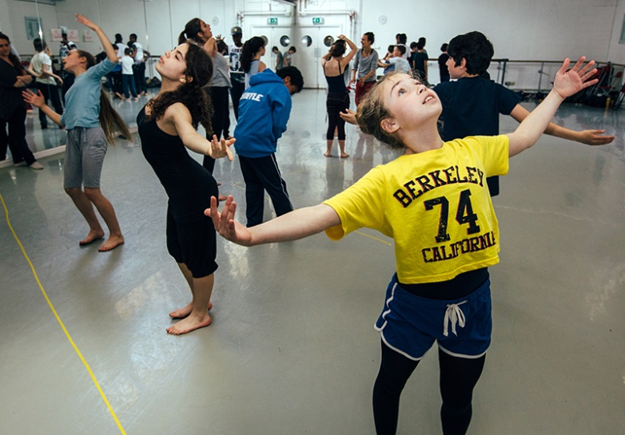
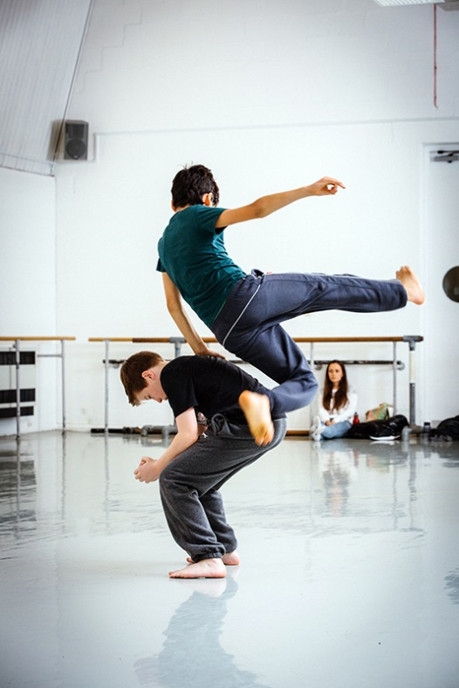

Schools Workshops

The creative team at The Little Ghost are excited to be able to offer a range of bespoke dance workshops for children between 5-11 years. The team will be available to go into a school of your choice and work with your students for up to 2 hours, taking them through creative and physical tasks exploring the themes found in the German folk tale “The Little Ghost” by Otfried Preussler.
Using elements of parkour as well as contemporary dance styles we work with a group of students playfully exploring material from the show.

The workshops will be led by a dancer from the company. All dancers hold a DBS check. Please note that workshops are only available on the day prior to the performance.

The school workshops are free of charge but will need to be organised by the venue and confirmed at least 1 month prior to the performance.

Pre Performance Workshops

The company are offering short pre-performance workshops to families with children aged 4 – 7 years as well as 7 – 9 years. These workshops are designed to enhance the audience’s experience through exploring the physicality, narrative and themes of the show prior to watching it.

The workshops are delivered by a dancer from the company and require a suitable warm, clean dance space with a fully functioning sound system as well as dance floor.

Please note that Pre-Performance Workshops are only available on the day of the show. Pre-Performance Workshops will need to start 1 hour prior to the performance.

Rehearsal Footage:

https://vimeo.com/165431827

Performance Trailer of last show (The Little Witch):

https://vimeo.com/112055552

Set Design Images:

